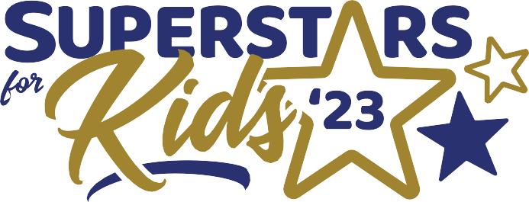***Thank you for helping us recognize outstanding community organizations and groups which are superstars for our kids.***

Organization Ally for Youth • Award Nomination

Please submit this form with the identification section completed plus no more than 2 pages which answer the questions below. Font must be no smaller than 10pt. No other material or papers will be considered. Email, mail or deliver your submission by the end of business on Friday, September 29th, 2023.

# Questions? Contact St. Joseph Youth Alliance, [sbraswell@youthalliance.org](mailto:sbraswell@youthalliance.org) | 816-232-0050

## What did the organization do to make a positive contribution for youth in Northwest Missouri?

Describe the commitment, whether it is ongoing or a one-time, the activities that engaged youth in a meaningful way, and whether the impact on youth was the result of direct or indirect activities.

**What are the tools the organization used as an adult advocate for youth in Northwest Missouri?** Describe how the nominee leverages education and/or experience to impact local youth, how they brought others together in the

community for a bigger impact and whether or not they identified assets at their disposal that could impact local youth.

## Explain the positive changes or benefits in the community due to the organization’s efforts.

Describe how the organization’s actions have instigated long-term change for youth in the community and how it impacted school readiness, school success, greater safety and health resource access and productive adulthood readiness for participating youth.

# Questions about the nomination form?

**Contact St. Joseph Youth Alliance staff at** [**sbraswell@youthalliance.org**](mailto:sbraswell@youthalliance.org) **or 816-232-0050.**

**Nominee Identification**

Organization or Group Name: Contact Name: Phone Number: Email address: Website: Submitted and Nominated by: Name: Phone Number: